|  |  |  |  |  |  |
| --- | --- | --- | --- | --- | --- |
| Date | 9-Dec-22 | | | Tester Name | Janette Paus |
| Environment | Penfax - Test 2 | | | Login used |  |
| Operating System | Windows | Version: 21H2 | Update Number: | | |
| Software Used | Select Software | Version: 107.0.1418.56 | Update Number: | | |
| Select Software | Version: | Update Number: | | |
| Application Release version | R22.4.1 | | | | |
| Test Case Title | E20.05a | | | | |
| Test Type | Regression | | | | |
| Test Scenario | Reverse a Payment out (LIRA, RRSP, Lump Sum) after Valuation | | | | |
| Expected Results | To reverse one of each of these types of payments and for the funds to go back into the member’s accounts as of the day the funds were withdrawn. For the payments with tax, the taxes will also be reversed. The breakage entries are reasonable. | | | | |
| Pass/Fail | Pass | | | JIRA# |  |

Find a payment in Batches/Payment production, hit search and find a payment that was created by a PEPP Pension Information Officer (PIO):

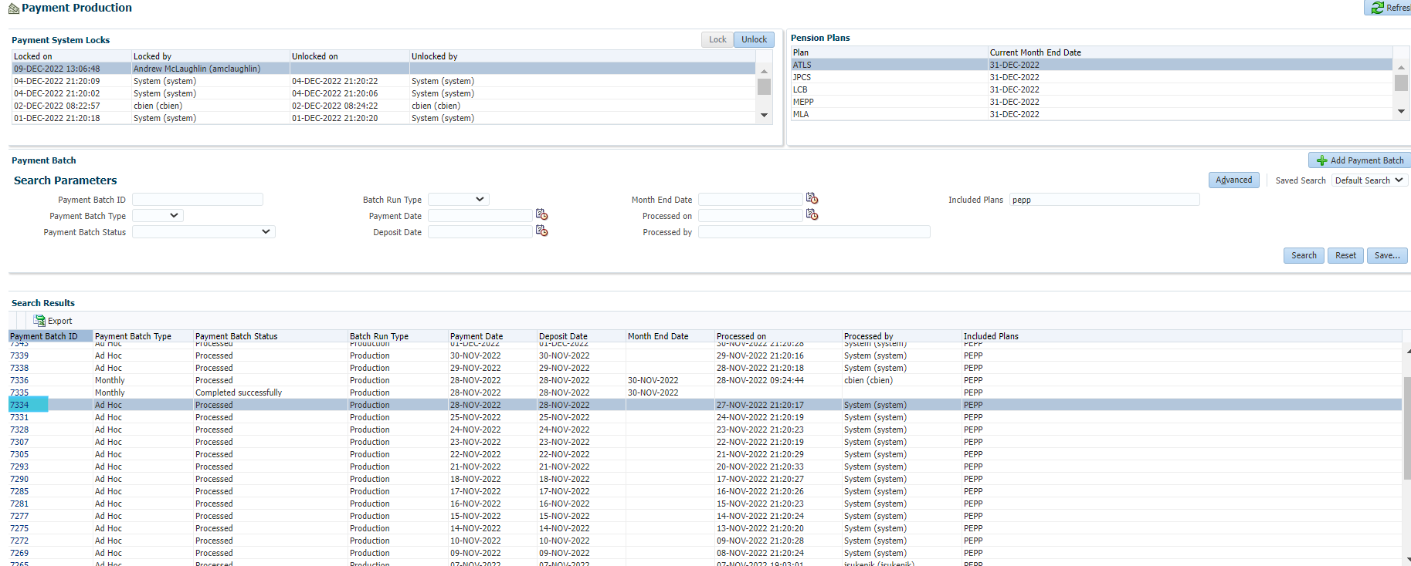

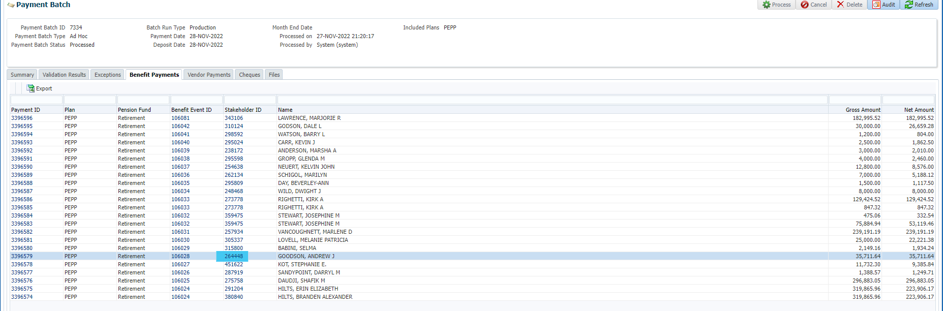



SID 310124 – Payment to member, payment processed in error

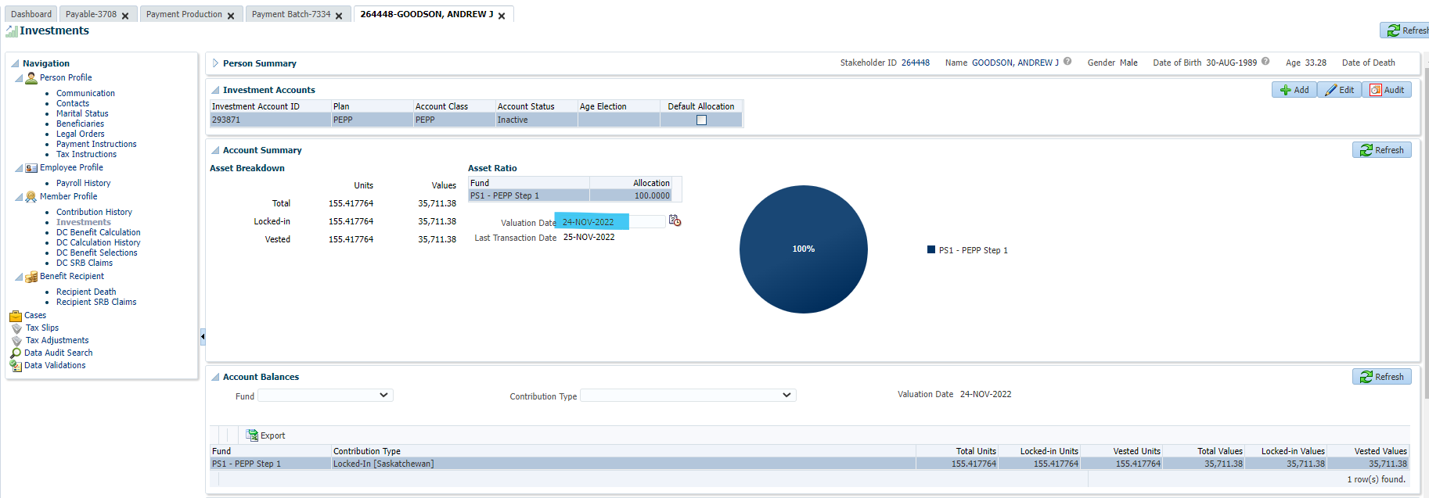

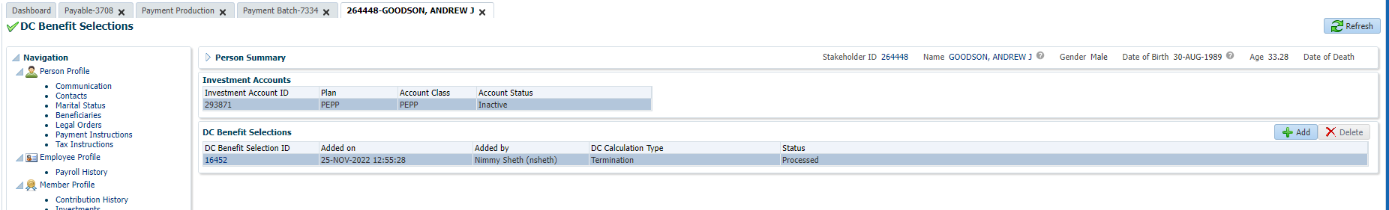

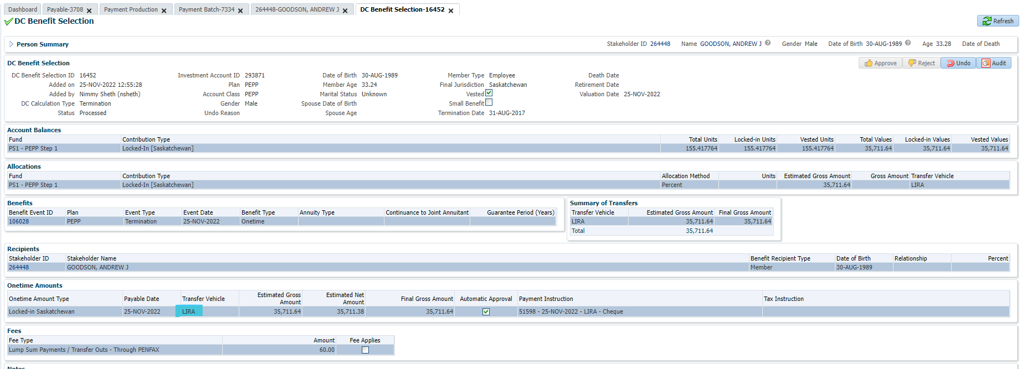

Go to DC Benefit Selection and click Undo to cancel the payment, using Reason “Calc should not have been processed” and click Save:

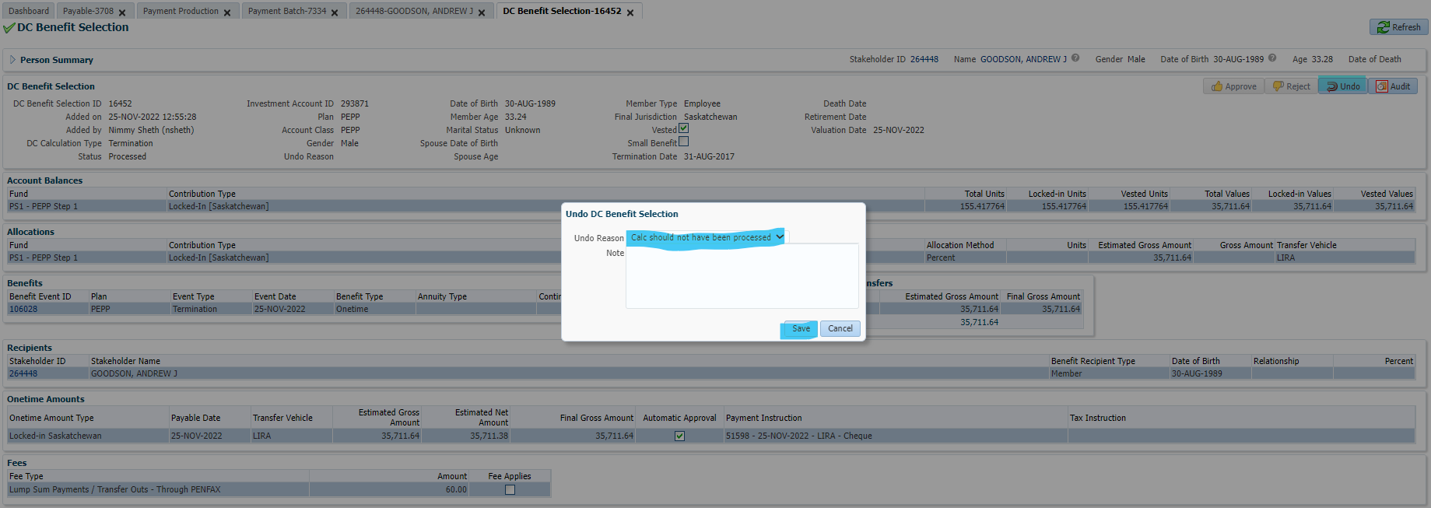

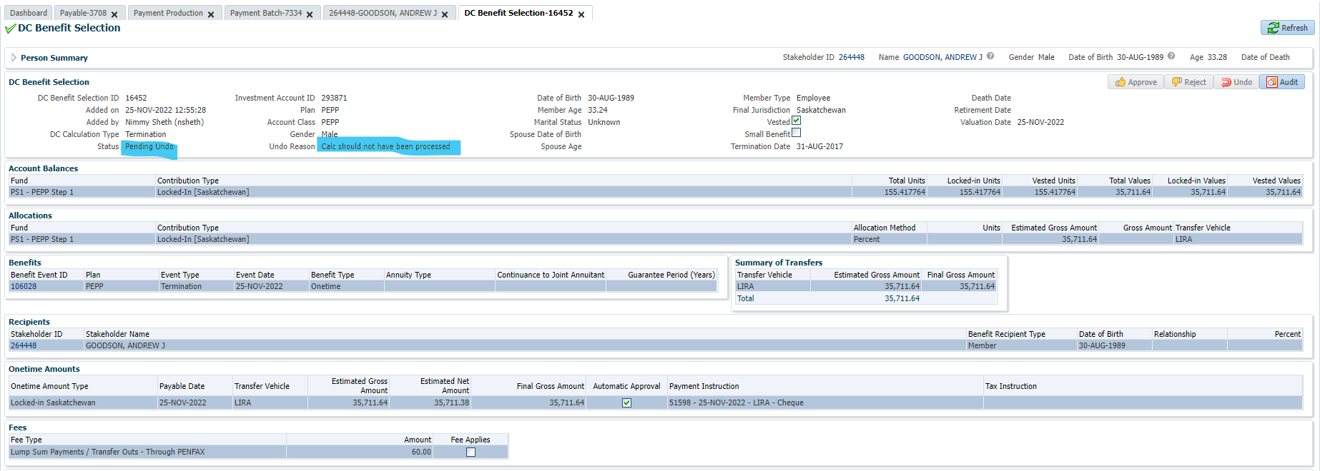

Go to Benefit Recipient, Onetime Amounts and click on Paid by Payment ID:

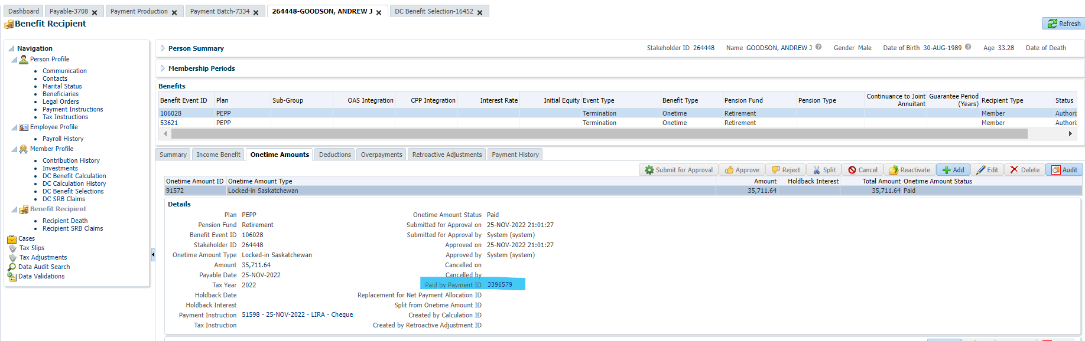

Click on Cancel Payment, select Paid in Error as Payment Cancellation Reason and click Save:

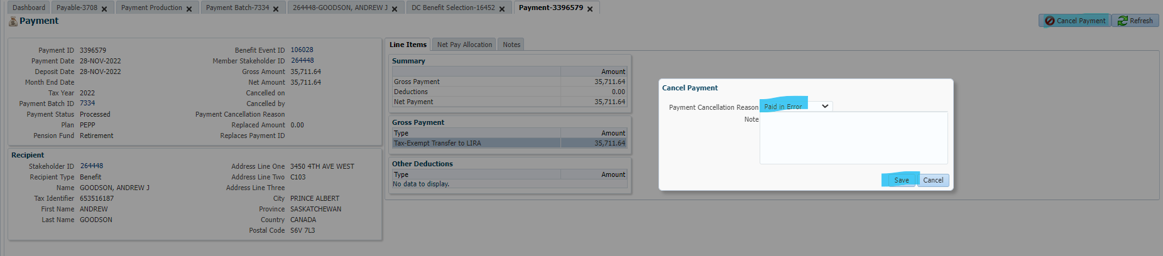

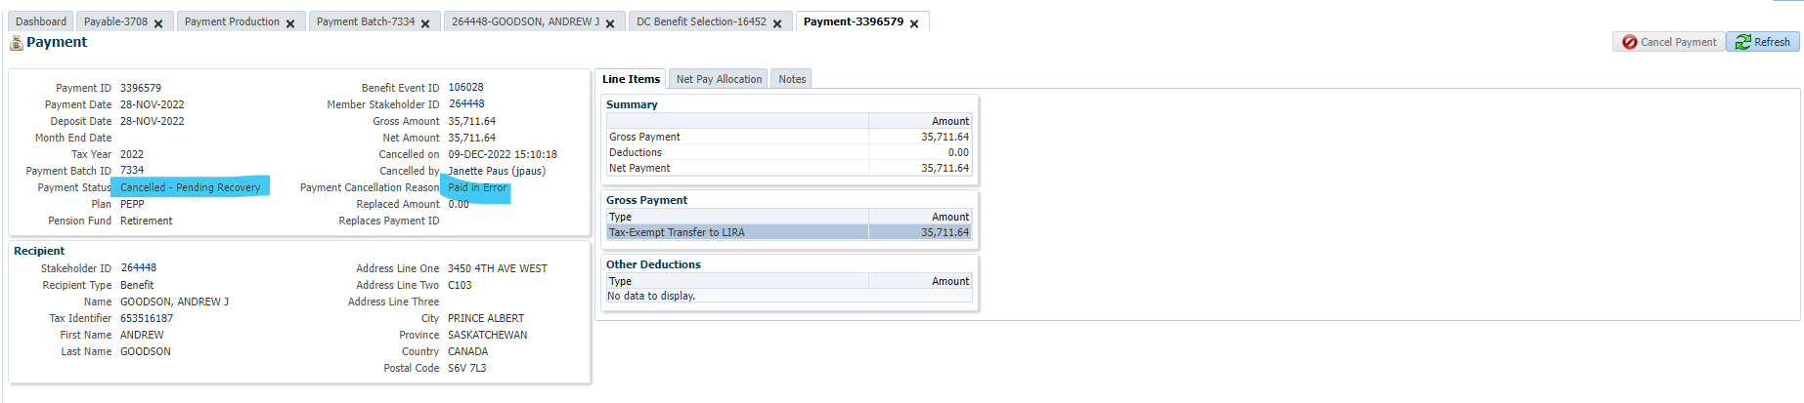

Go to Benefit Recipient, Overpayments, add Recovery of payment amount and save, click Mark Payment as Recovered and click Save:

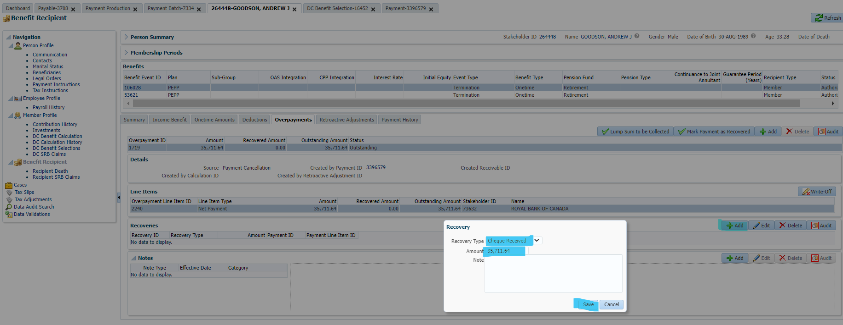

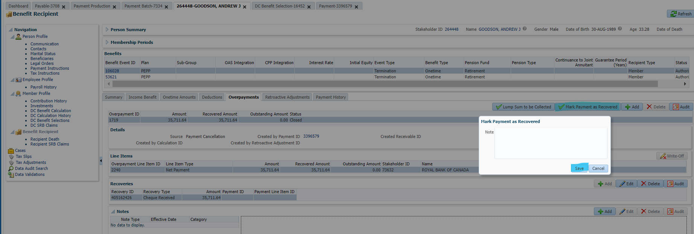

Next day, confirm units went back into account:

